**Program to swap two numbers**

Imports System

Module Program

Sub Main(args As String())

Dim x, y As Integer

Console.WriteLine("Enter the value of x")

x = Console.ReadLine()

Console.WriteLine("Enter the value of y")

y = Console.ReadLine()

x = x + y

y = x - y

x = x - y

Console.WriteLine("After swapping values of x and y are{0}", x & y)

'Console.WriteLine(x)

'Console.WriteLine(y)

End Sub

End Module

Output:

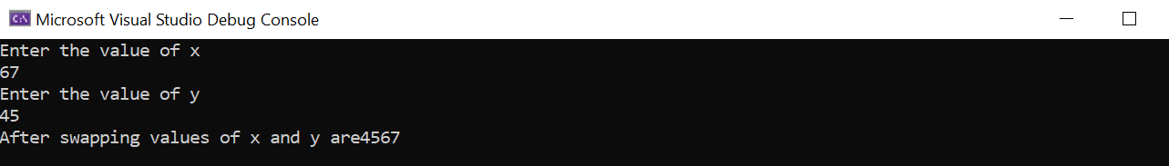

**Program to sort an array**

Imports System

Module Program

Sub Main(args As String())

Dim names(3) As String

Console.WriteLine("Enter names")

For name As Integer = 0 To names.Length - 1

names(name) = Console.ReadLine()

Next

Array.Sort(names)

Console.WriteLine(" Sorted Names are: “)

For name As Integer = 0 To names.Length - 1

Console.WriteLine(names(name))

Next

End Sub

End Module

**Output:**

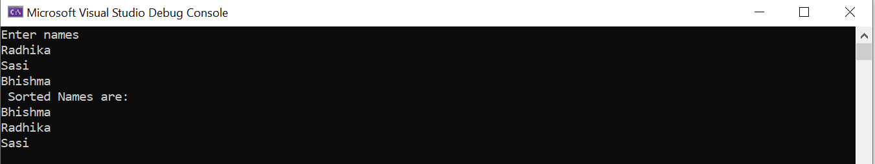

**Program to multiply two matrices**

Imports System

Module Module1

Sub Main()

Dim temp As Integer = 0

Dim matrix1 As Integer(,), matrix2 As Integer(,)

Dim row1 As Integer, col1 As Integer, row2 As Integer, col2 As Integer, i As Integer, j As Integer, k As Integer

Console.WriteLine("Please insert no. of rows in matrix_1 :: ")

row1 = Integer.Parse(Console.ReadLine())

Console.WriteLine("Please insert no. of columns in matrix_1 :: ")

col1 = Integer.Parse(Console.ReadLine())

matrix1 = New Integer(row1 - 1, col1 - 1) {}

Console.WriteLine("Please insert no. of rows in matrix_2 :: ")

row2 = Integer.Parse(Console.ReadLine())

Console.WriteLine("Please insert no. of columns in matrix_2 :: ")

col2 = Integer.Parse(Console.ReadLine())

matrix2 = New Integer(row2 - 1, col2 - 1) {}

If col1 <> row2 Then

Console.WriteLine("Multiplication is not applicable!!!")

Console.WriteLine("Note : Number of columns of matrix_1 must be equal to Number of rows of matrix_2.")

Else

Console.WriteLine("Please Input the values for matrix_1")

For i = 0 To row1 - 1

For j = 0 To col1 - 1

matrix1(i, j) = Integer.Parse(Console.ReadLine())

Next

Next

Console.WriteLine("Please Input the values for matrix_2")

For i = 0 To row2 - 1

For j = 0 To col2 - 1

matrix2(i, j) = Integer.Parse(Console.ReadLine())

Next

Next

Console.Clear()

Console.WriteLine("You have entered :: ")

Console.WriteLine("Matrix 1 ::")

For i = 0 To row1 - 1

For j = 0 To col1 - 1

Console.Write(matrix1(i, j))

Console.Write(" ")

Next

Console.WriteLine()

Next

Console.WriteLine("Matrix 2 ::")

For i = 0 To row2 - 1

For j = 0 To col2 - 1

Console.Write(matrix2(i, j))

Console.Write(" ")

Next

Console.WriteLine()

Next

Console.WriteLine("Product of Matrix_1 & Matrix_2 is ::")

For i = 0 To row1 - 1

For j = 0 To col2 - 1

For k = 0 To row2 - 1

temp = temp + (matrix1(i, k) * matrix2(k, j))

Next

Console.Write(temp & " ")

temp = 0

Next

Console.WriteLine()

Next

End If

Console.Read()

End Sub

End Module

Output:

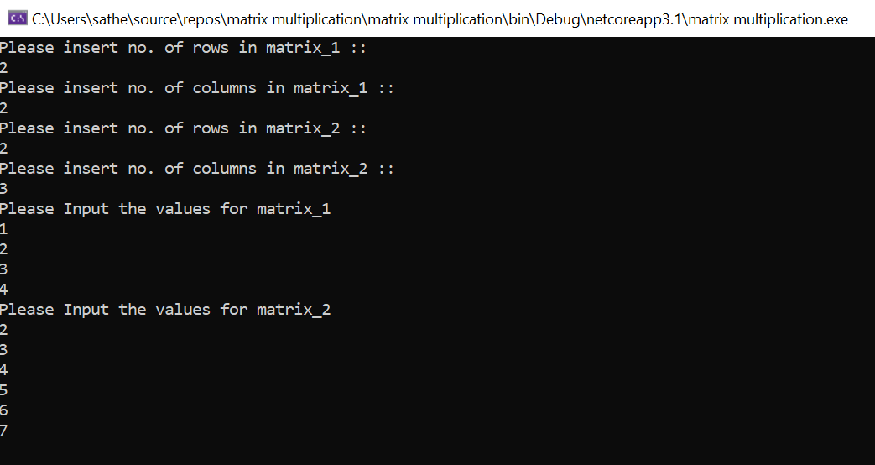

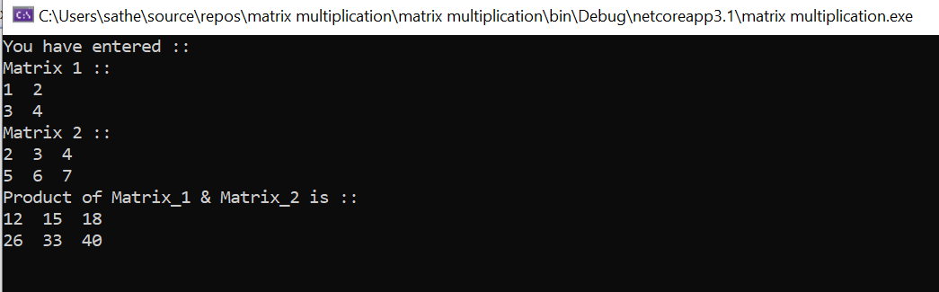

**Program to implement function**

Imports System

Module Module1

Function Factorial(ByVal num As Integer)

Dim result As Integer

If num = 1 Then

Return 1

Else

result = Factorial(num - 1) * num

Return result

End If

End Function

Sub Main()

Console.WriteLine("Factorial = {0} ", Factorial(5))

Console.ReadKey()

End Sub

End Module

Output:

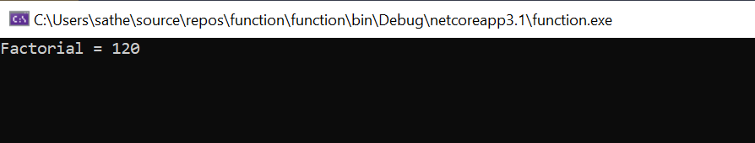

**Program to implement class**

Imports System

Module Module1

Sub Main()

Dim user As Users = New Users("Kishore Kumar", 40)

user.GetUserDetails()

Console.WriteLine("Press Enter Key to Exit..")

Console.ReadLine()

End Sub

Public Class Users

Public Property UName As String

Public Property UAge As Integer

Public Sub New(ByVal name As String, ByVal age As Integer)

UName = name

UAge = age

End Sub

Public Sub GetUserDetails()

Console.WriteLine("Name: {0}, Age: {1}", UName, UAge)

End Sub

End Class

End Module

Output:

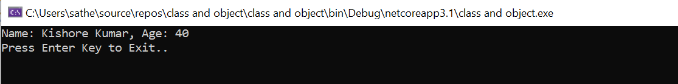

**Program to implement try,catch…finally**

Imports System.IO

Module exceptionProg

Sub division(ByVal num1 As Integer, ByVal num2 As Integer)

Dim result As Integer

Try

result = num1 \ num2

Catch e As DivideByZeroException

Console.WriteLine("Exception caught: {0}", e)

Finally

Console.WriteLine("Result: {0}", result)

End Try

End Sub

Sub Main()

division(25, 0)

Console.ReadKey()

End Sub

End Module

Output:

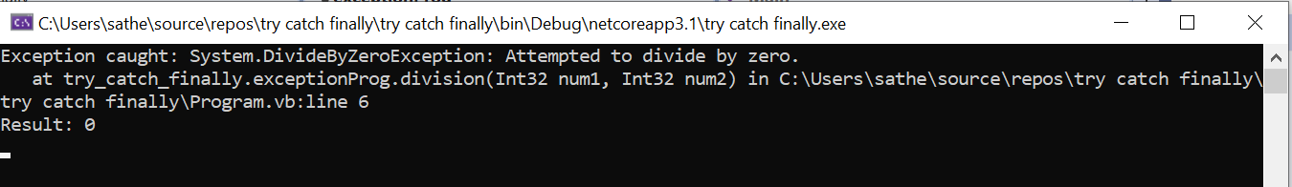

**Program to print**

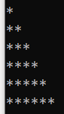

Imports System

Module Module1

Sub Main()

Dim row, col, noofrow As Integer

Console.WriteLine("Enter number of rows")

noofrow = Console.ReadLine()

For row = 1 To noofrow Step 1

For col = 1 To row Step 1

Console.Write("*")

Next

Console.Write(vbNewLine)

Next

End Sub

End Module

Output

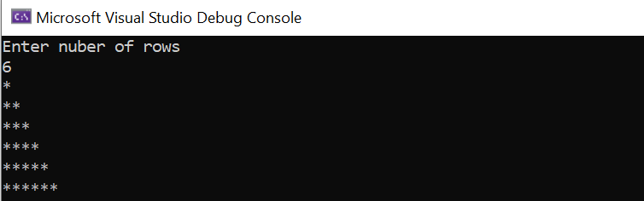

Program to print

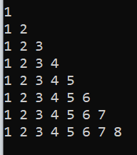

Imports System

Module Program

Sub Main(args As String())

Dim i, j, n As Integer

Console.Write("Enter the number of lines:")

n = Console.ReadLine()

For i = 1 To n

For j = 1 To i

Console.Write(j & " ")

Next

Console.WriteLine()

Next

Console.ReadLine()

End Sub

End Module

Output:

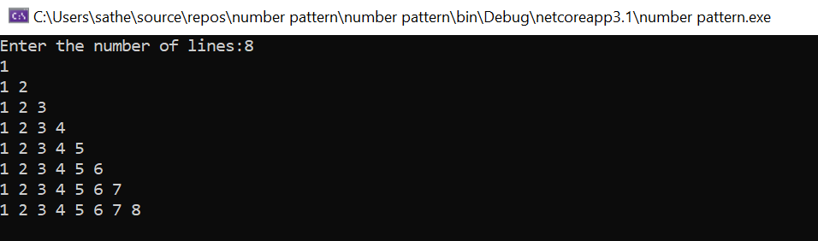

**Program to implement message box (YES/NO type) on button click event.**

Public Class Form1

Private Sub Form1_Load(sender As Object, e As EventArgs) Handles MyBase.Load

End Sub

Private Sub Button1_Click(sender As Object, e As EventArgs) Handles Button1.Click

Dim answer As Integer

answer = MsgBox("Text", vbQuestion + vbYesNo + vbDefaultButton1, "Message Box")

If answer = vbYes Then

MsgBox("You clicked Yes Button")

Else

MsgBox("You clicked No button")

End If

End Sub

End Class

Output:

